Additional material
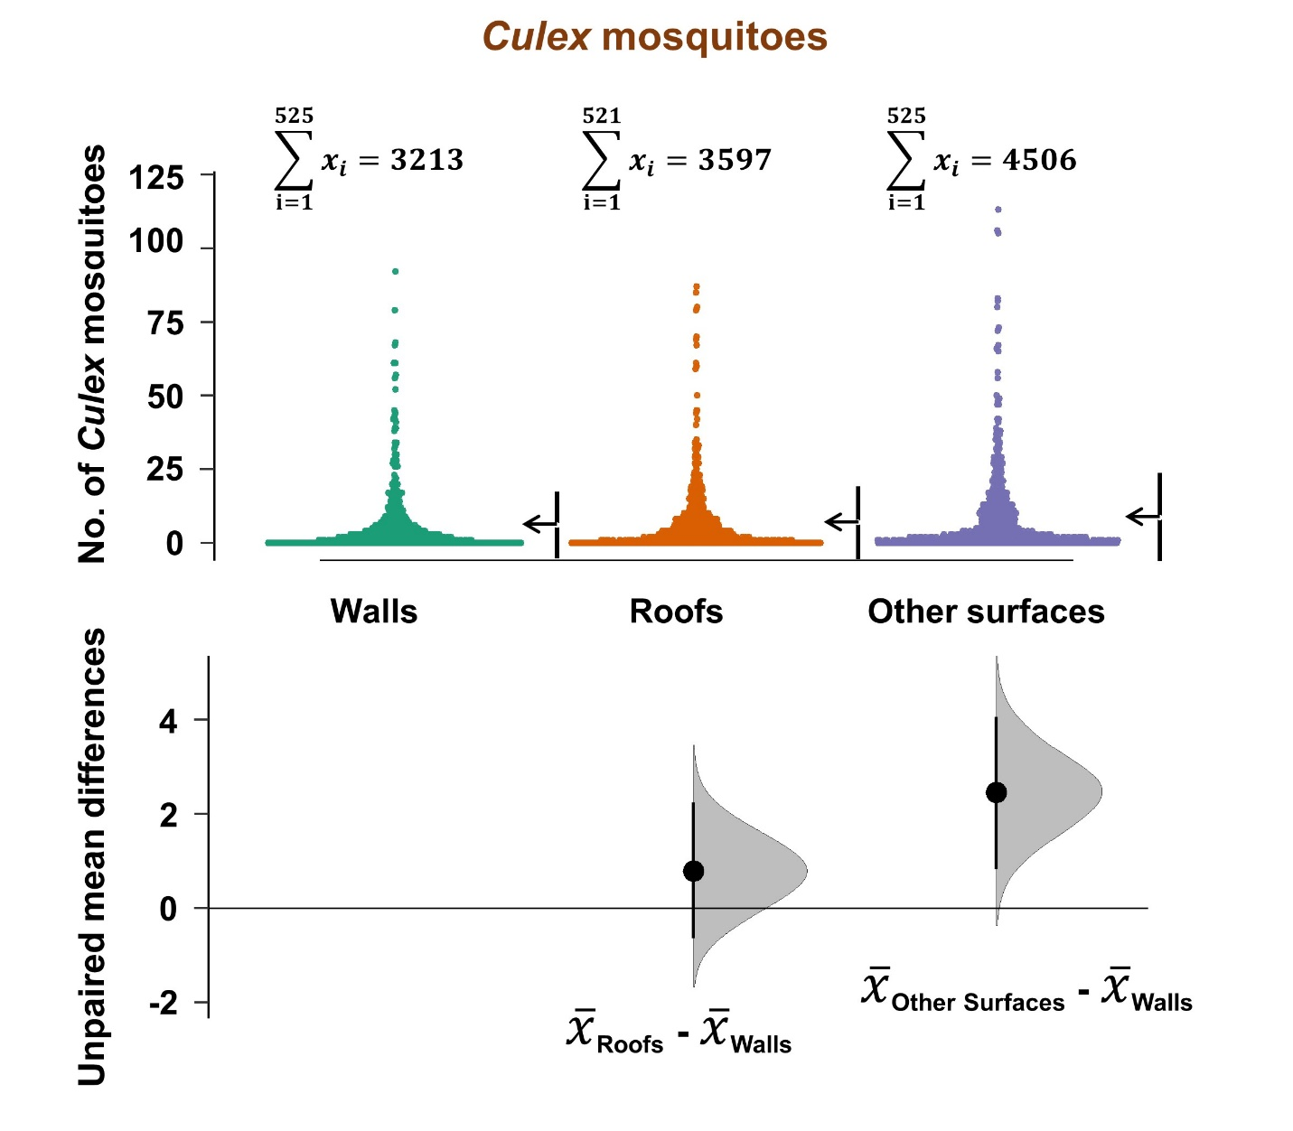
Figure S1. Overall densities of Culex mosquitoes, from different resting surfaces in houses. This data is aggregated for all house types in the study area. Estimation plots are provided to depict distribution of residuals between collections from roofs or other surfaces, and the collections on walls. The number of mosquitoes resting on either roofs or other surfaces are considered significantly higher or lower based on how far the means of the residuals are above or below the reference line.

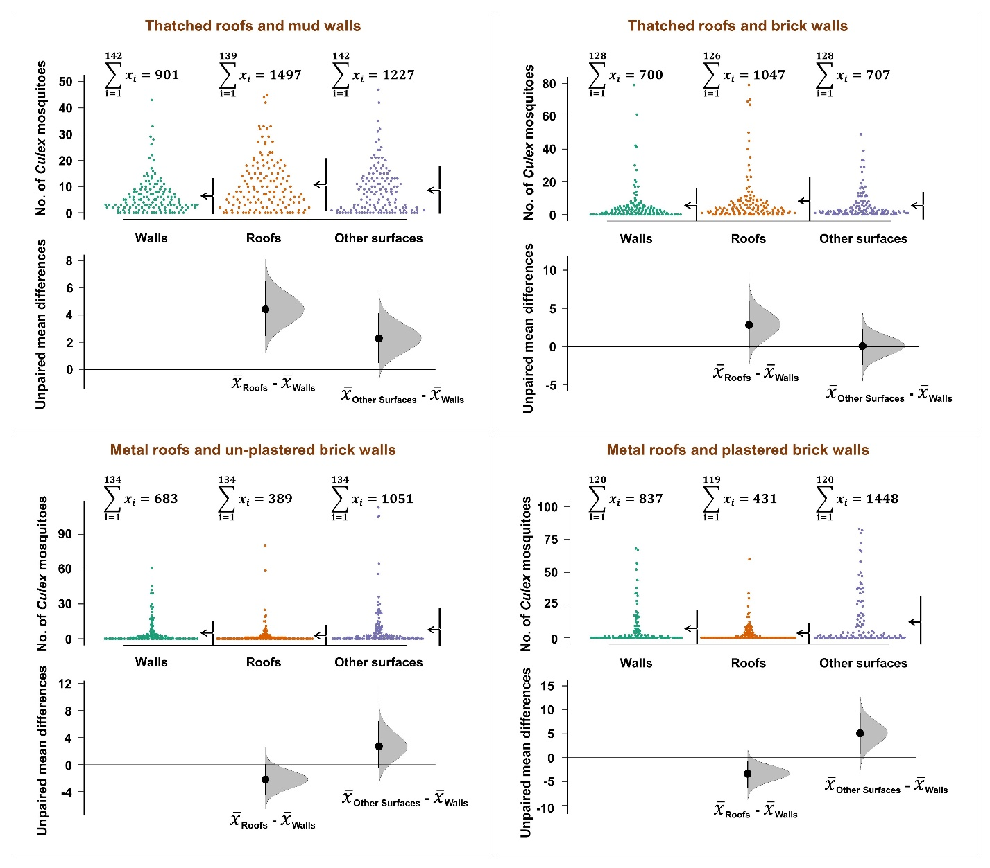
Figure S2. Comparison of densities of Culex mosquitoes, from different resting surfaces in different house types. Estimation plots are provided to depict distribution of residuals between collections from roofs or other surfaces, and the collections on walls. The number of mosquitoes resting on either roofs or other surfaces are considered significantly higher or lower based on how far the means of the residuals are above or below the reference line.

